**Ideation Phase**

**Brainstorm & Idea Prioritization**

|  |  |
| --- | --- |
| Date | 24 June 2025 |
| Team ID | LTVIP2025TMID20421 |
| Project Name | Streamlining Ticket Assignment For Efficient Support Operations |
| Mentor Name | Dr Shaik Salma Begum |
| Maximum Marks | 4 Marks |

**Brainstorm & Idea Prioritization:**

Brainstorming was conducted as an initial step to generate a wide range of creative ideas for designing the Streamlining Ticket Assignment For Efficient Support Operations project. This phase provided an open and collaborative environment, allowing all team members to contribute freely without judgment. The focus was on generating as many ideas as possible, encouraging out-of-the-box thinking that could later be refined into actionable concepts.

Key aspects of the brainstorming process included:

* Encouraging volume over immediate value, to ensure all potential solutions were surfaced.
* Welcoming and building upon unconventional or novel ideas.
* Fostering collaboration, where team members supported and enhanced each other's suggestions.
* Using a shared template to capture ideas in a structured manner, making it easy to review and prioritize them later.

Following the idea generation phase, the team moved to idea prioritization. This involved:

* Reviewing the list of proposed features and solutions.
* Assessing feasibility within the constraints of the ServiceNow platform and project timeline.
* Prioritizing ideas that aligned with project objectives, such as scalability, ease of use, and automation.
* Selecting concepts that provided maximum impact for household expense tracking while being achievable during the internship duration.

This structured approach to brainstorming and prioritization helped the team shape the core features and design elements of the project, ensuring that the final solution addressed both creative possibilities and practical considerations.

**Step-1: Team Gathering, Collaboration and Select the Problem Statement**

**Step-2: Brainstorm, Idea Listing and Grouping**

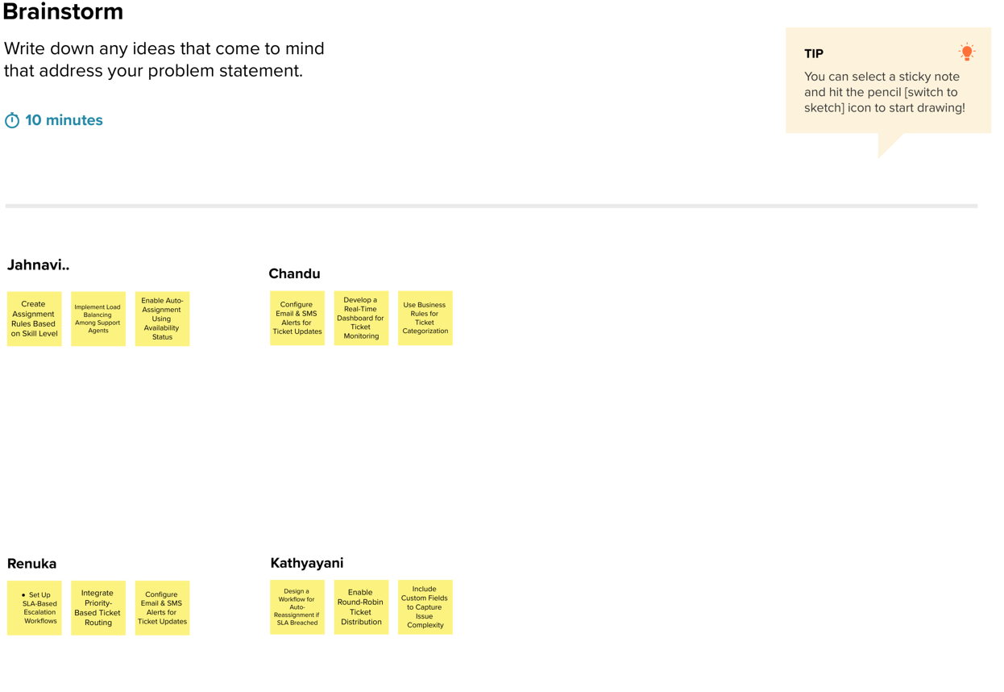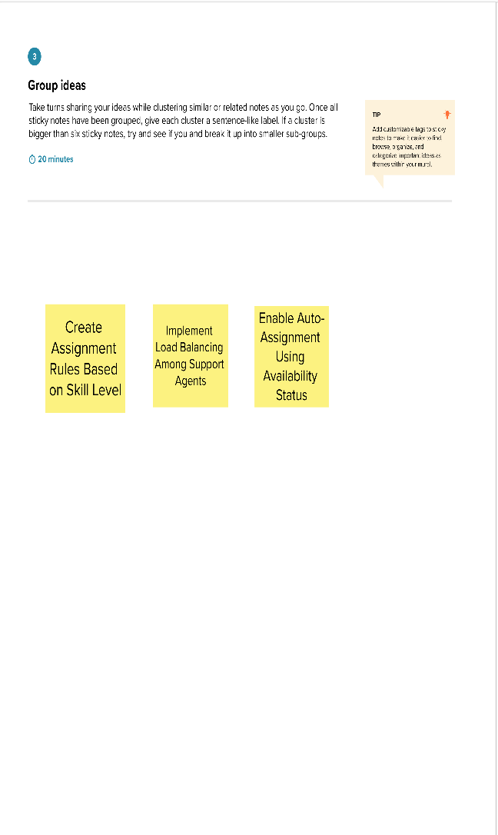

**Step-3: Idea Prioritization**

